Distributing Your Game

Introduction
Once you feel you are ready for players to come on and test your game you will need to create a file for your players to download.

Preparation
One of the first things you may want to do is to reset the config.ini found in “/client/data files/”. This is so that your players aren’t automatically limited to your settings.
A reset config.ini should look something like this:
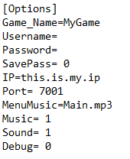
You may also want to change the IP to your IP and the Port to whatever port your game uses as well as deleting the “maps” and “logs” folders.

Which files to include
In order for your game to run you will need to include the following highlighted files and folders:
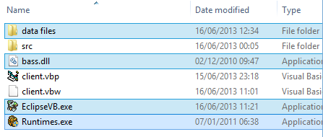

Packaging your game
Once you have selected the above files right-click them and click “Send To > Compressed Zip Folder”. This will create a compressed file of all your files and folders. You can now upload this to your website or a filesharing website (such as http://filebeam.com or http://mediafire.com).
Remember to instruct your players to install the “Runtimes.exe” exactly like you did in the first tutorial.

